

Jaarrapport 2021

Joseline Humanity Support Foundation

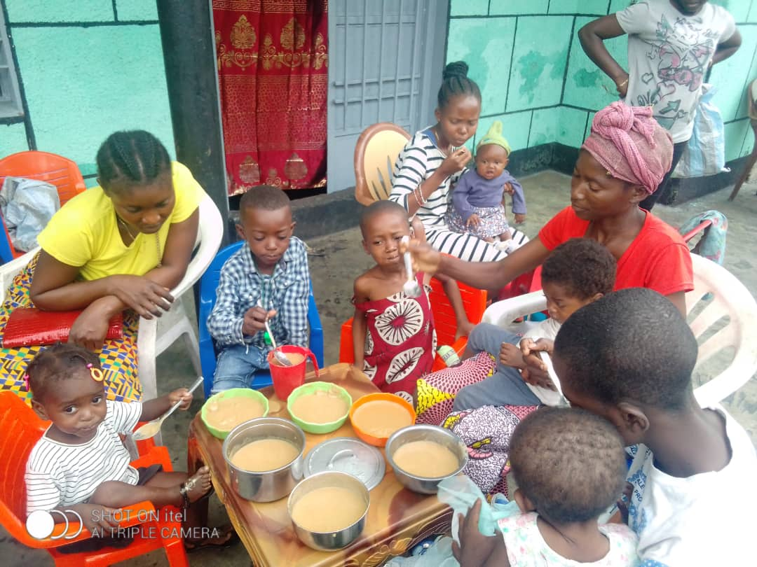

|  |  |  |
| --- | --- | --- |
| **ACTIVA** |  |  |
|  | **2021** | **2020** |
| **Liquide middelen** |  |  |
| Bank | € 4.709 | € 3.971 |
|  | € 4.709 | € 3.971 |

|  |  |  |
| --- | --- | --- |
| **PASSIVA** |  |  |
|  | **2021** | **2020** |
| **Kapitaal** |  |  |
| Eigen vermogen | € 4.859 | € 3.971 |
|  | € 4.859 | € 3.971 |

|  |  |  |  |  |
| --- | --- | --- | --- | --- |
| **Resultatenrekening 2021** |  | |  | |
|  | **2021** | | **2020** | |
| Donaties | € | 7.437 | € | 8.057 |
| Projecten | € | 5.581 | € | 5.299 |
| Vervoerskosten | € | 778 | € | 245 |
| Reis en verblijf | € | 15 | € | 38 |
| Webhosting | € | 122 | € | 106 |
| Reclamekosten | € | 2 | € | 10 |
| Bankkosten | € | 50 | € | 47 |
| Resultaat | € | 888 | € | 2.313 |